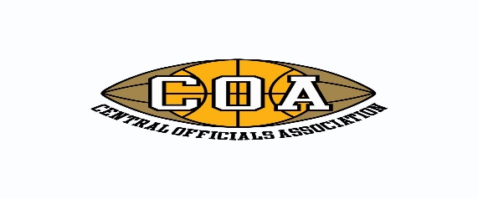
Hall of Fame Nomination Form
The Central Officials Association was founded in 1929 as a Basketball and Football Association to recruit, train and develop sports officials. The COA inducted their first member official into their Hall of Fame in 1971 and has been recognizing member officials with this honor annually ever since.
This honor is intended to recognize member officials who have achieved success in their officiating career that distinguishes them from other officials in their sport. Whether the official had success on the high school level, collegiate level or both any COA member is eligible to be nominated for the Hall of Fame. The honor is intended for those who have significant achievements in their chosen sport, whether it be having work State Finals, College Bowl games, Conference Championships, an extra ordinary number of years in officiating or any other accomplishment that you believe distinguishes them from their peers. Please provide specific details about the nominee to assist the Board members in thoroughly understanding and appreciating the accomplishments of the nominee. If necessary, attach additional information to support your nomination. Return completed forms to Mike Luzzi at heyref32@sbcglobal.net or 6921 W. Hobart, Chicago, IL 60631 by March 11.
Name of official making the nomination: .
Name of Member Official being nominated: .
Sport(s) nominee works or has worked: Basketball Football Dual
Number of years nominee has been officiating or been a COA member: .
Description of why the Official is being nominated for the COA Hall of Fame:
.

.

.

.

.

