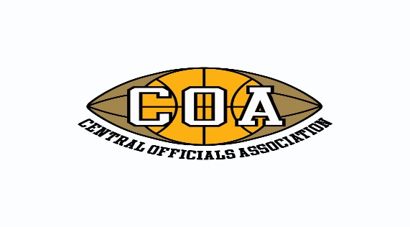
Ellie Hasan Award Nomination Form
The Central Officials Association was founded in 1929 as a Basketball and Football Association to recruit, train and develop sports officials. The COA created the Ellis Hasan Award in 19 in the name of legendary COA member, Ellis Hasan. The award is given annually to an individual who has displayed the traits and dignity which Ellie was known to have.
This honor is intended to recognize member officials who have achieved success in their officiating career that distinguishes them from other officials in their sport. Whether the official had success on the high school level, collegiate level or both any COA member is eligible to be nominated for the Hall of Fame. Please provide specific details about the nominee to assist the Board members in thoroughly understanding and appreciating the accomplishments of the nominee. If necessary, attach additional information to support your nomination. Return completed forms to Mike Luzzi at heyref32@sbcglobal.net or 6921 W. Hobart, Chicago, IL 60631 by March 11.
Name of official making the nomination: .
Name of person being nominated: .
Description of why the individual is being nominated for the Ellie Hasan Award:
.

.

.

.

.

.

